Discussion Groups

 | We need people to be involved in Discussion Groups for this project.
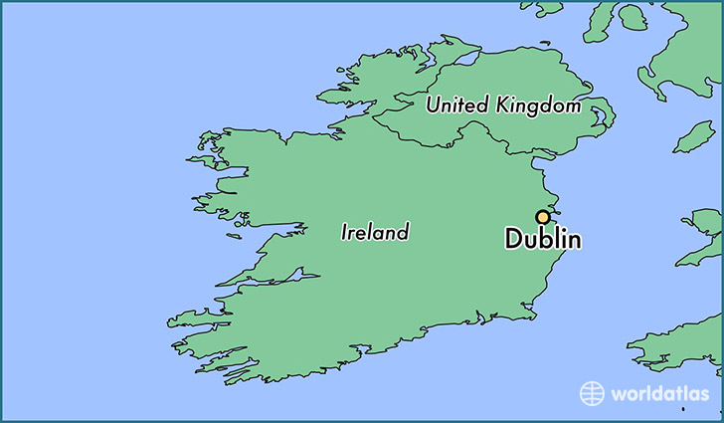 | The Discussion Groups will meet in Dublin.
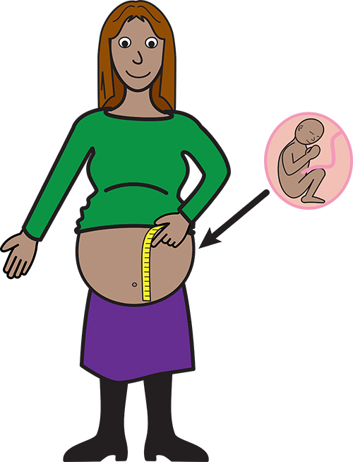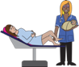 | The first Discussion Group will talk about pregnancy and childbirth.
 | The second Discussion Group will talk about abortion.
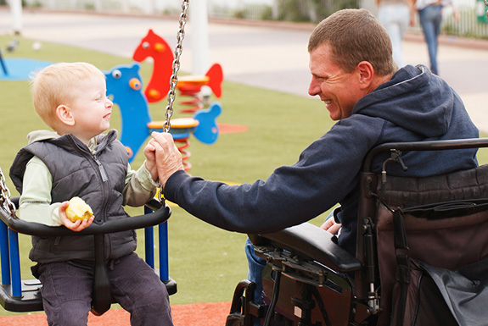 | The third Discussion Group will talk about parenting.
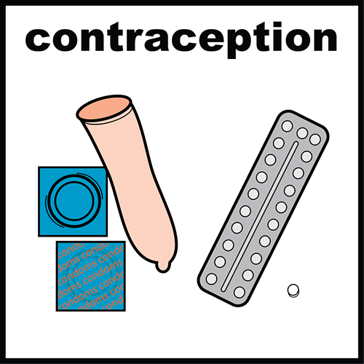 | The last Discussion Group will talk about family planning.
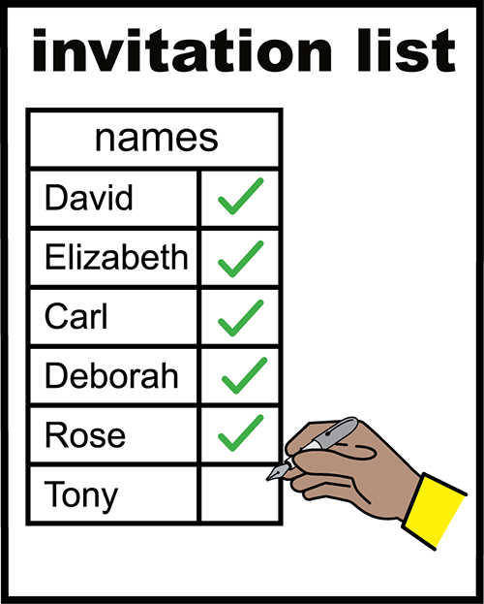  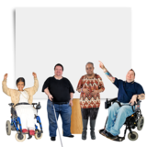  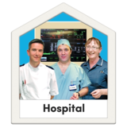 | The Research Team will invite people to be members of the Discussion Group:  To be a member of the Discussion Group you must:  Be a person with a disability  OR  Work in law  OR  Work in healthcare  OR  Work in social care.
 | You must give your opinion on the topic being discussed.
 | We will support you to do this if you need it.
 | Do you want to join the Discussion Group?
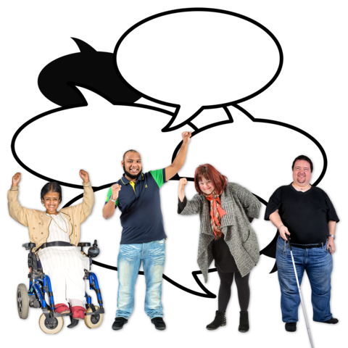 | You can take part in one or more of the Discussion Groups.
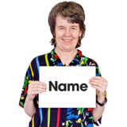 | Name
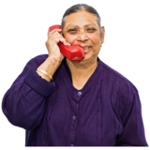 | Phone Number
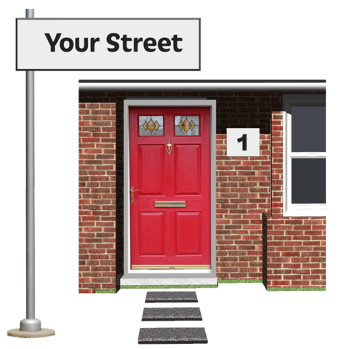 | Address
 | Email
 | Please tick ✓
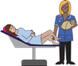 | I would like to attend the meeting on pregnancy and childbirth.
 | I would like to attend the meeting on abortion.
 | I would like to attend the meeting on parenting.
 | I would like to attend the meeting on family planning.
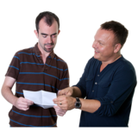 | Tell us why you want to be a part of the Discussion Group.

