Join the Stakeholder Group

This project will have a Stakeholder Group.

The Stakeholder Group will have 3 meetings.

To be a member of the Stakeholder group you must be

A person with a disability

OR
Work in law

OR
Work in healthcare

OR
Work in social care

The Stakeholder Group will give advice to the researchers.
The Stakeholder Group will let other people know about the research.
The Stakeholder Group meetings will be private.

 | Do you want to join the Stakeholder group?
 | Name
 | Address
 | Phone number
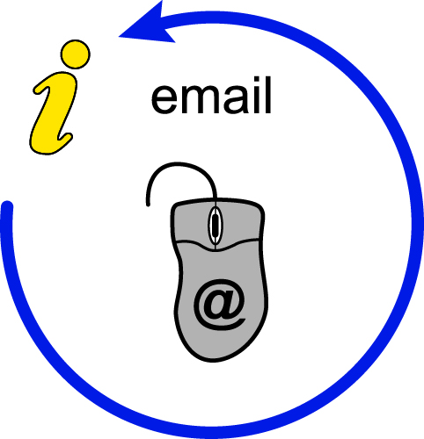 | Email

Rules of the Stakeholder Group

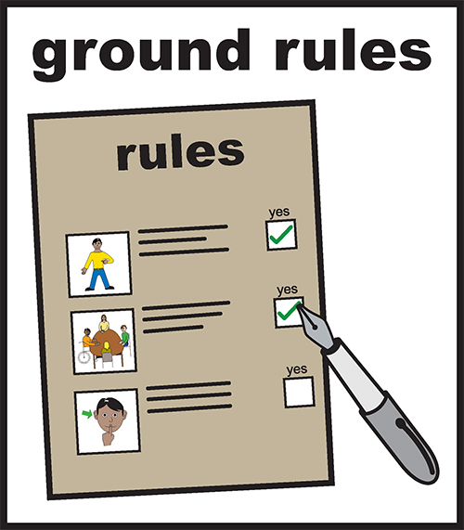 | You must agree to the rules to be a member of the Stakeholder Group.  You must come to all 3 meetings.
 | The Stakeholder Group will help the Research Team with questions about laws.
 | The Stakeholder Group will help the Research Team with questions about policies
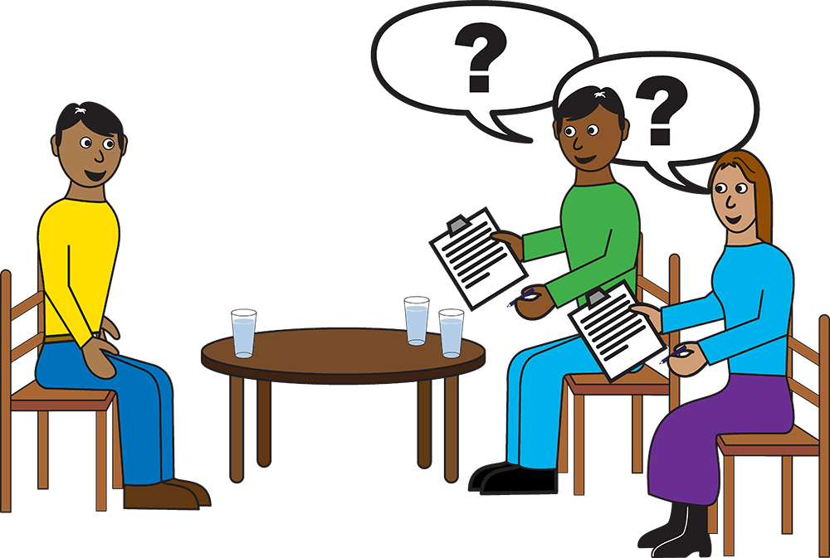 | The Stakeholder Group will help the Research Team to find people to tell their story and to be a key informant.
 | Everyone will get a chance to speak
 | Everyone will respect each other’s opinions.
 | The Stakeholder Group will let people know what we found out in our research.

